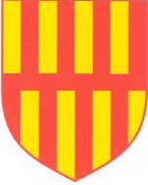 |  | 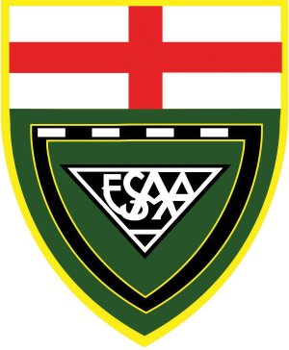

ESAA Track & Field Championships 2023
Alexander Stadium, Birmingham.
Friday 30 June / Saturday 01 July
Northumberland Team
Magnus Riddell | JB | 800 metres
Eli Adams | JB | High Jump
Calum Sayers | JB | Triple Jump
Elliot Kelso | IB | 3000 metres
Joseph Close | IB | 800 metres
Rhys Brunton | IB | Long Jump & Relay
Luke Pichler | IB | Long Jump & Relay
Zac Old | SB | 800 metres
Josh Blevins | SB | 1500 metres
James Tilley | SB | 3000 metres
William De Vere Owen | SB | 3000 metres
Edward Gardiner | SB | Discus
Alexandria Hodgson | JG | Hammer
Poppy Old | IG | 800 metres
Lauren Creaby | IG | 800 metres
Senna Gorvett | IG | 300m Hurdles & Relay
Leila Thompson | IG | Shot
Sadie Parker | IG | Long Jump & Relay
Kaitlyn Waddell | IG | Hammer
Holly Waugh | SG | 1500m
Jess Sails | SG | 1500m
Georgina Mabbott | SG | 400m Hurdles
Anna Fitzpatrick | SG | High Jump
Jessica Doyle | SG | Shot

Depart: Morpeth Bus Station at 1.00pm / Royal Grammar School at 1.30pm
St John’s Hotel, Solihull, B91 1AT

